Problem Statement & Scope Statement
Problem statement
Problems that are facing by the users while using the current Library system
The current system of the college doesn’t allow it uses a manual writing and that is so risky because paper can be lost due to different reason.
1. As it is not available online every student calls up to find out if the book is available or not. - Too many calls to answer.
2. Every time a student calls for a book you have to check the racks for the availability of the book. - Too much of physical work.
3. If some one reserves the book, he’s not sure if he definitely can get the book as the previous student may not return in time..
4. Fines have to be calculated manually.
5. Students have no idea to check their account.

Project Scope
Project Title : Library Management System
Date : 01-NOVEMBER 2016 Prepared By : DENGA A
Project Justification:
This project is basically updating the manual library system into a computer system based application so that the users can know the details of their account ,availability of books etc.,
Product Characteristics and Requirements :
1. Secured database.
2. User tracking
3. Search books
6. Checking the availability of books.
7.Students will get an call before the due date in order to avoid fines
Project Management Deliverables:

Project plan, Research finding report, Work breakdown structure, Scope statement, Project charter, Training manuals, lessons learned report etc.,
Product-related deliverables :
Research reports ,design documents, software code, hardware ,test plan, project benefit measurement plan etc.,

Project Success Criteria: Our main goal is to complete this project within allotted dead line and also within the budget allotted. It is necessary to develop a method for capturing the benefits while the Library management system is being developed, tested, and after it is rolled out. If the project takes a little longer to complete or costs a little more than planned, the firm will still view it as a success if it has a good payback and helps promote the firm’s image as an excellent management organization

1. Statement of Work

1. Scope of Work
The on-line Library Management System should manage different types of library resources such as Books, Magazines, News Papers and any other resources which the management feels in the future could form a resource. A resource can be categorized to facilitate searching, sorting and managing the resources. This can be exemplified by dividing the books as being in IT or Business category. Students and college Staff can borrow resources from the library. There need not be a stipulated return date for the borrowed resource depending upon the individual to whom the resource has been lent to. If a stipulated return date has been specified and the resource is not returned within this stipulated due date, a fine may be imposed on the resource user. The basic fine amount should be updatable by the management if a need to do so arises in the future. The System should also allow for a provision to block a resource, where by an individual can borrow the blocked resource once it is returned by the current borrower.

2. Location of Work
The client for this project is the library which is inside the campus.
3. Period of Performance
The duration of the project is 6 months. All the tasks are equally distributed among team members to accomplish the goal of completing the project.

4. Deliverables Schedule

Deliverable | Date Due
Written report part I:  Statement of work and Project Plan | Week 3
Written report part II:  Project scope & problem statement/ requirements specification | Week 6
Written report part III:  Problem analysis and research report | Week 8
Written report part IV:  Prototype implementation or practical experimental work | Week 11
Written report part V:  Review of results and statement of findings (including test reports) | Week 12
Written report part VI:  Status reports and project diary | Ongoing assessment at supervisor meetings
5. Applicable Standards:
The project “Library Management System” follows various programming standards.

6. Acceptance Criteria:
The acceptance criteria for the users are
- The system has to communicate with the database.
- librarian can easily search the book with in less time
- Maintaining the account details of the user.
- Users can block the book, view the book.
7. Additional Requirements:
Qualified team members are very important for project. Team members have to have a basic knowledge in the following areas:
- A sound knowledge in programming languages such as ASP, Java and dot net and a knowledge of databases such as MySQL, SQL server or Access.

Software Design Document

1. Introduction

Software Design Document is the design work product that formally documents the design of the software components. Software Design Document gives us the detailed description about the flow of the project.

1.1 Purpose

Software Design Document defines the modules, interfaces and the interaction between modules and interfaces. It also helps us in giving information about how the system will look the appearance of user interfaces and the information about static and dynamic view of the system.

The detailed design document is the developer's blueprint. It provides precise directions to software programmers about how basic control and data structures will be organized. Typically, the Detailed Design Document consists of tables and diagrams that translate the functional specification into data structures, data flows, and algorithms.

The Detailed Design Document is written before programming starts. It describes how the software will be structured, and what functionality will be included. This document forms the basis for all future design and coding.

The designer's goal is to develop a model that achieves the functional requirements while operating within key constraints, such as performance goals and hardware. The main goal is create a design which is simple, easily understood, easily communicated, and easily built and easily tested design.

1.2 Scope

The Library Management System is being developed for the college. The important modules that are going to implement in the proposed system.

Calculating the fines.
Reservation of books.
Searching book depends upon i) Book_id ii) Book_name.
Log in, depends upon admin Id.
Administrator has all the privileges to add, modify and delete the librarian.
My account facility for the student so that he can view his account details.
1.3 Intended Audience

This document is intended for use by technical developers. This document also includes sections relevant to the operational and maintenance group.
The intended audiences for this document are:

The team members of Innovative library Solutions.
The administrative staff of the college who is the client.
The Project Supervisor

This document will be reviewed frequently by the above audiences to check if the different phases of the project are being completed by meeting the given requirements. It is expected that the intended audience shall critically review this document for functional accuracy and revert to team with their feedback and comments within a less time.

1.4 Constraints

The team has to follow the rules specified in the team contract. The team is proceeding to develop an appropriate system; however the design might slightly changed to meet the client requirements.

1.5 Definitions, Acronyms, and Abbreviations

The acronyms that are constantly used in the document include the following.

SPMP – Software Project Management Plan.
SDD – Software Design Document.
SRS – Software Requirements Specification.
UML – Unified Modelling Language
RUP – Rational Unified Process
OMG – Object Management Group
ERD – Entity Relationship Diagram
DFD – Data Flow Diagram

The definitions that are constantly used in the document include the following.

Unified modelling language - The Unified Modelling Language™ - UML - is OMG's most-used specification, and the way the world models not only application structure, behaviour, and architecture, but also business process and data structure.

Rational Unified process - “Rational Unified Process Model is a software engineering process which provides a disciplined approach to assigning tasks and responsibilities within a software development organization for the successful development of software.”

2.0 System Overview

The Library Management System is a system application which is able to manage different types of library resources such as Books, Magazines, News Papers and any other resources which the management feels in the future could form a resource

Basically, there are three views for the convenience of the user. In the catalogue view the user can find the available books in library, in My Account view the librarian can know the details of books he borrowed or add,delete,modify etc and in Administrator view the user can have all the rights to view the report of books that have been issued., Advanced search ,searches according to author ,book_name, book id .

Context Diagram summarizes all processing activity and also helps users to view highest level of system with system boundaries. The system overview can be shown in the form of context diagram.

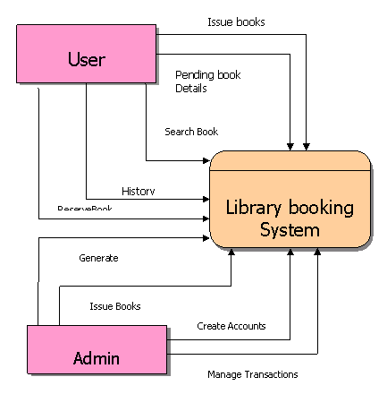
2.2 Data flow Diagram

Dataflow diagram is the graphical system model that shows all main requirements for an IS in one diagram
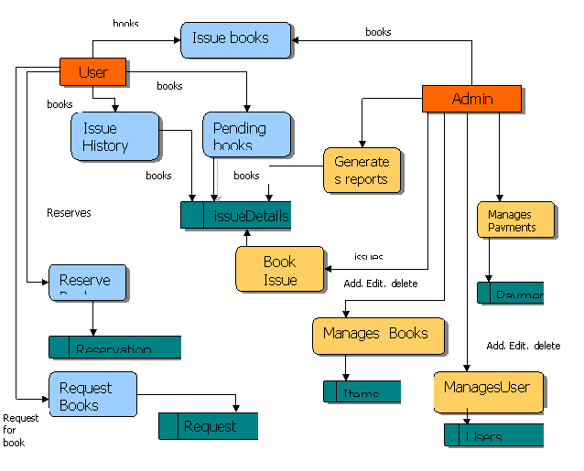
3. System Architecture: The Three Tier Architecture:

To develop software for Library management system the architecture that we are implementing is Three Tier Architecture. The User Interface Layer, Application Logic Layer and Data Storage Layer together called as Three Tier Architecture.

3.1 User Interface Layer

The User Interface Layer will consist of everything shown directly to the client. This Layer will communicate only with the Application Logic Layer. This Layer will also be responsible for initial validation of any user inputted data. Any validation that requires communication to the Data Storage Layer will however be completed at the Logic Layer.

3.2 Application Logic Layer

The Business logic for our project is Visual Basic. It will be responsible for providing a secure connection to the Data Storage Layer and formatting information received from the SQL Server for presentation to the User Interface Layer. Scripts that return user specific data, such as advisory stream selection will be run on the Data Storage Layer.

3.3 Data Storage Layer

The Data Storage Layer will record all information required by the Logic and User Interface Layer. This data will include Subject details for the Streams, and general user and admin user information. All passwords stored in the database will be encrypted to prevent unauthorized access. Within the Data Storage Layer a collection of SQL Queries will provide access to the data in a meaningful way.

4.Architectural Design
4.1Architectural Description

Name: Library First Form
Type: opening page
Description:
First form contains the loading that load for few seconds and then it close and when it close is where it show user selection where you select user that you want to use is either Admin or Librarian

Name: Library Second Form
Type: user page
Description:
If the user wants to check their account details, he / she should know the password and username, there is no sign up from for admin section reason being we trying to prevent people for signing up for admin and make changes or deleting some important informations. Changes it can be only done by the admin

Name: Admin Login
Type: user page
Description:

Admin button is clicked it asks the user username and password, if the login name and password is valid the user is directed to Admin section. And if the password and username are not valid it gives you a message that says invalid admin username or password.
After username and password when they correct it closes a form and shows a please wait form that load for seconds and the pop up another form that contains different panels.
The first panel show all admin user information (usernames and password) and the second panel is where you able to add librarian,
By adding a librarian you should enter librarian_id, librarian_name, librarian_surname, librarian_username, librarian_password, librarian_re enter password, librarian cell number and also librarian email number.

The third panel is where you view all the the librarian and be able to see their information such as name, surname, address and password.

The fourth panel it allows admin to remove or delete the librarian, here admin select librarian that he/she wants to delete from the database and once librarian is removed he/ she cannot have access to borrow or issue book or able to add students

And the last panel it shows the report or generate reports for all books that has been issued and the issued date and also the return date and student and the librarian who issued the book.

Name: Librarian Login
Type: user page
Description:
When button for librarian is clicked it asks the user username and password, if the login name and password is valid the user is directed to librarian section. And if the password and username are not valid it gives you a message that says invalid librarian username or password.
After username and password when they correct it closes a form and shows a please wait form that load for seconds and the pop up another form that contains different sections. Manage student and manage books.

Name: Manage Books
Type: Controling
Description:

This section it contains everything about the books it has more panels than other section (admin and students)

The first panel is all about adding a new book to the database by using book_id book name, book description, author, publisher and also a year that has been released.

The second panel views or shows all the books that are on the database from A-Z.

The third panel update book that are already in database incase if they change something on a book or book id as an example.

The fourth panel it delete or remove book or books in the database for example if book is no longer available in the school or campus it should be removed from the database.

The firth panel filter books that are on the database by using book id, book name, author,
By filtering it simply save time and help the librarian to not waste time on checking books from 1 – 100 or A-Z.

The next panel it`s for librarian that he/she use when student wants to borrow a book.
On this panel librarian enters his / her details (librarian id, librarian name), and student details (student number, student name) and issued dates and return dates and book details (book id, book name)
And then student will be able to borrow books when those details or names are provided.

The next panel it shows all books that are issued and dates like when did they issued and when are they gonna be returned.

The last panel is for librarian to generate reports for a librarian to see how many students borrow and retuned books.

Name: Manage Student
Type: Controling
Description:

Librarian has all the rights of the complete system. This page or section contains of different panels.

The first panel it allows librarian to add new student to the database so that the student can be able to borrow the book. Librarian add student using or entering student number, student name, student surname, student address and student cell number.

The second panel consist of form or list that display or show all students that are on the database all their names, and everything that they has register with.

The third panel is for librarian if incise where student changed the address or name or cell number this panel is for updating information about the student.

The fourth panel is for librarian to remove or delete student from database for example if student graduate from the school or change the school.

The last panel it shows or allow librarian to search or filter students from the database by using student number because student number is unique and each student have its own student number there is no way that student can have same student name and librarian can be able filter students by using student name.

5. Some screen shots of the library system

Loading Page


Select User

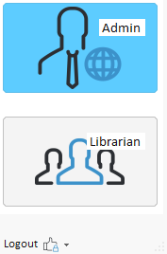

Login page for Administration page
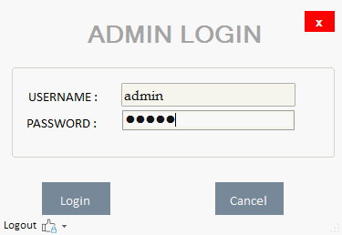

Message that shows when you entered invalid details

I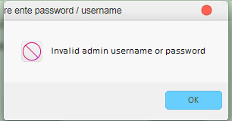
When you enter valid details



Admin Home Page
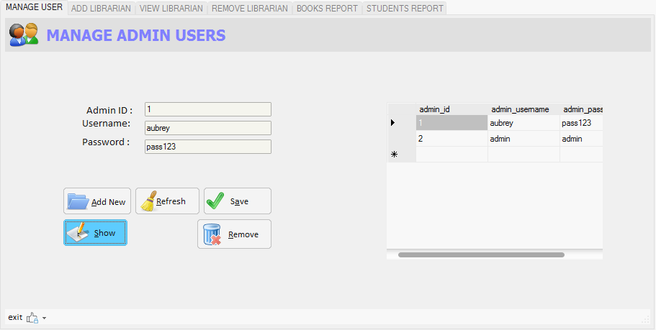

Librarian Home Page
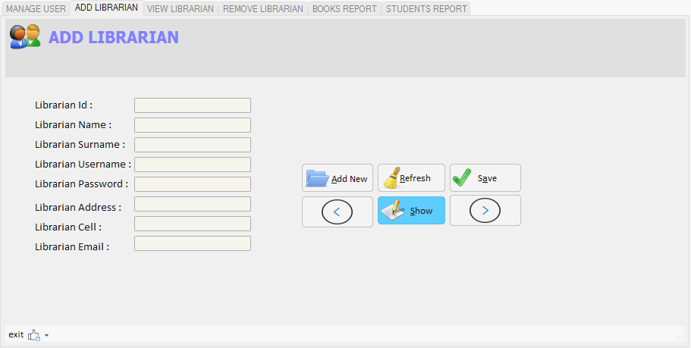
View Librarian Home Page
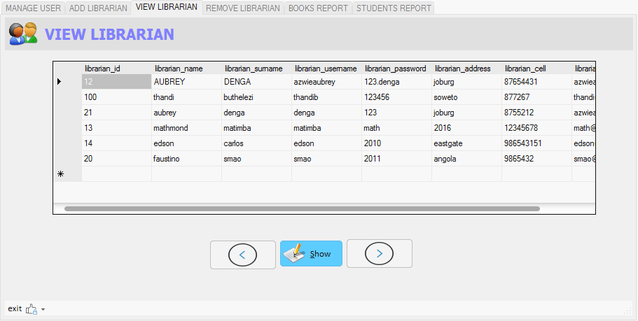
Remove Librarian Home Page
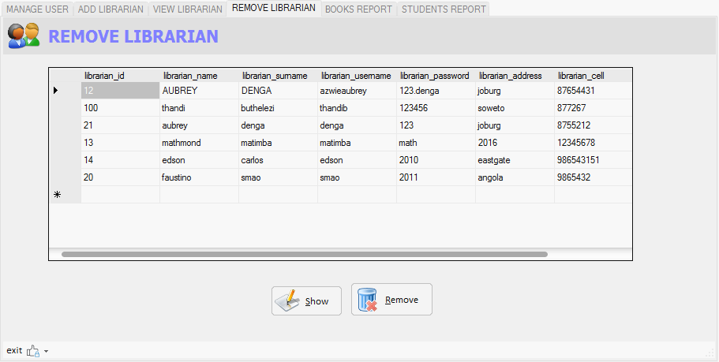
Book Report Home Page
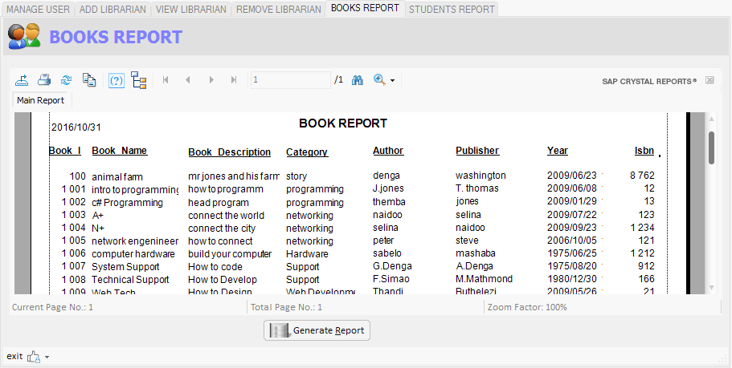
Student Report Home Page
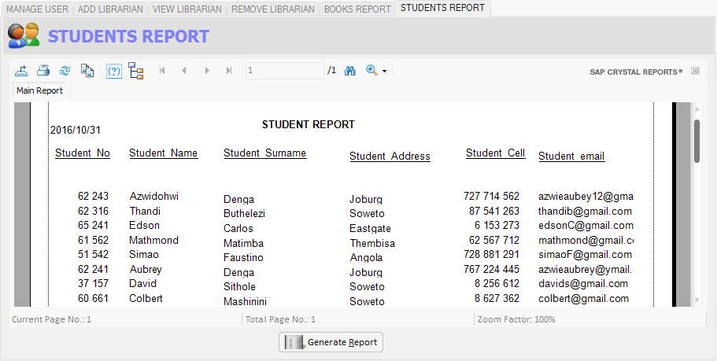

Librarian Login
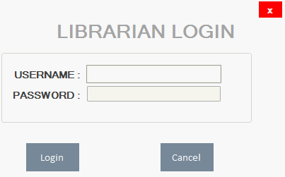

When you enter invalid details it shows this error message
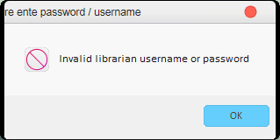
When you enter valid details takes you to this page.

When it finish loading it shows you this page

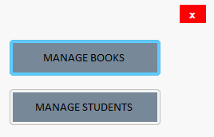
When you click or select Manage Books, this is the first panel(add new book)
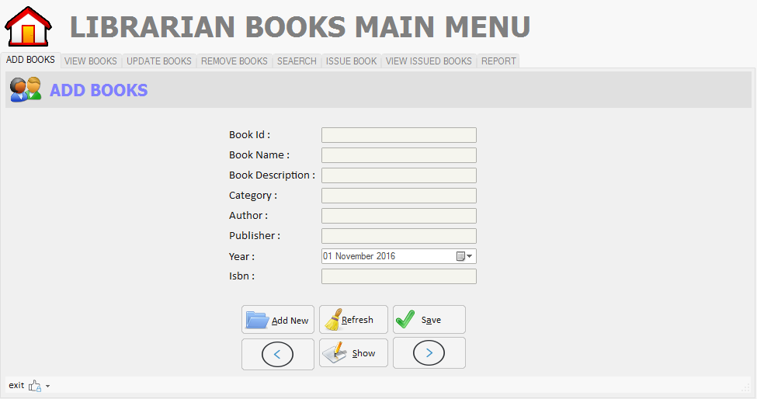

The second panel of manage books(view all books)
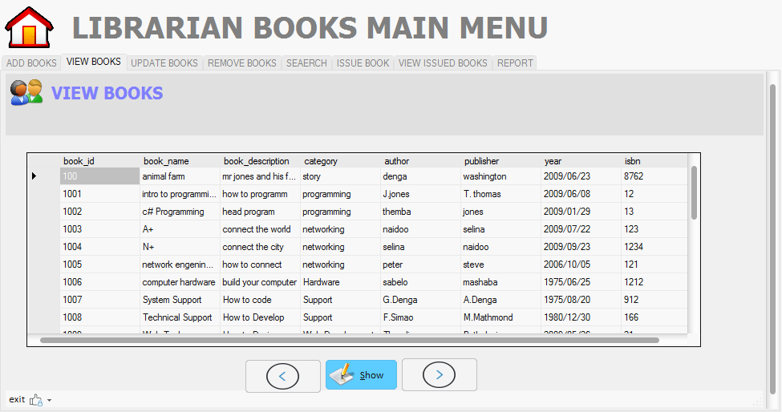
Third panel of manage books(update books)

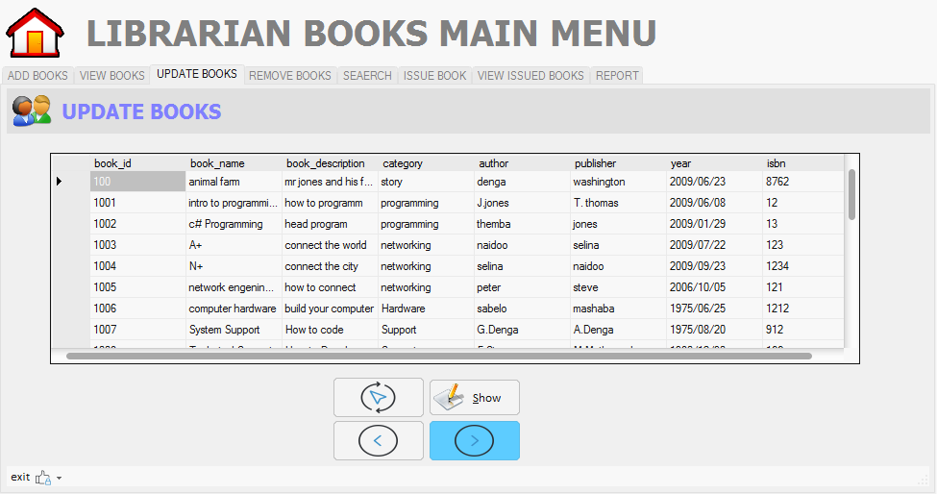

The fourth panel of manage books(removing books)
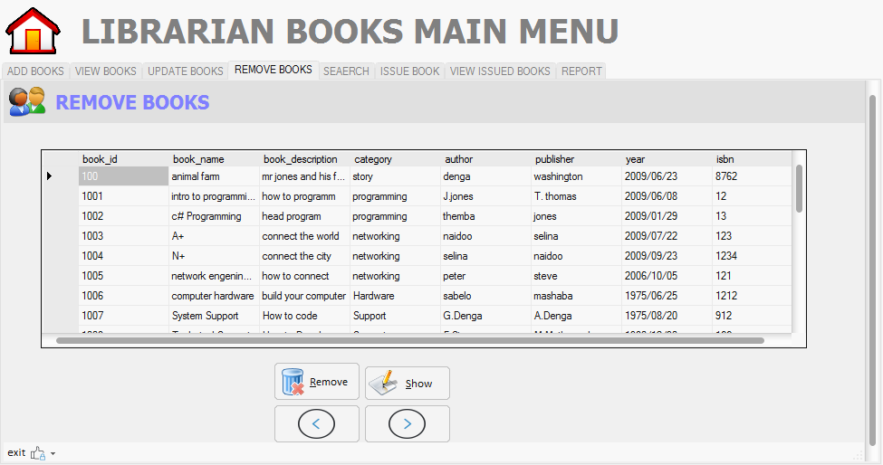

The firth panel of manage books(search books)
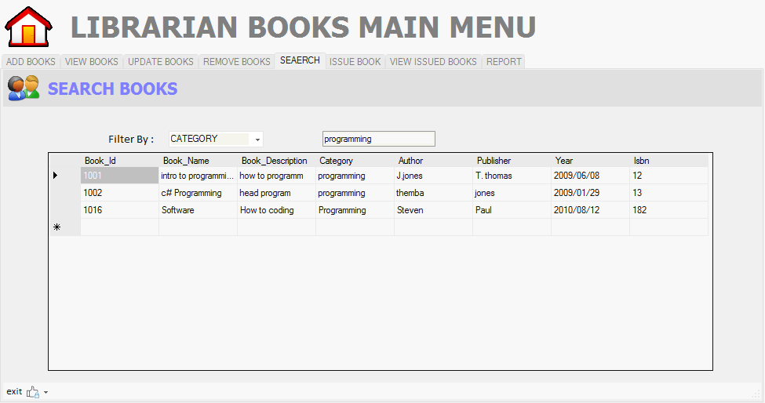

6th panel for manage books(issue book)

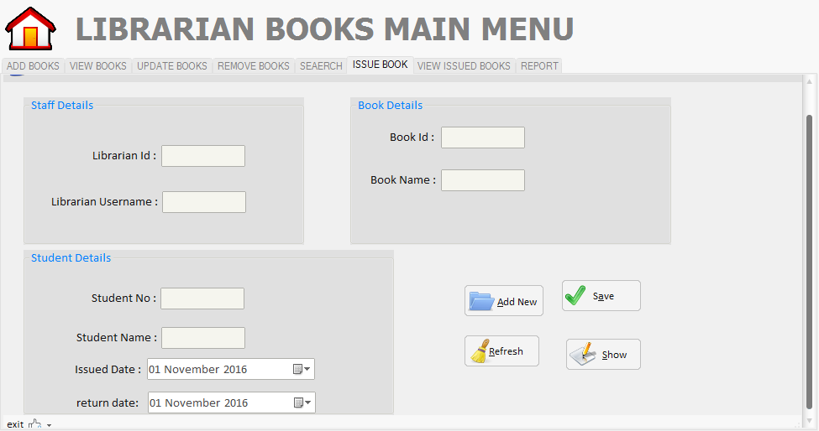

7th panel of manage books(view issued books)
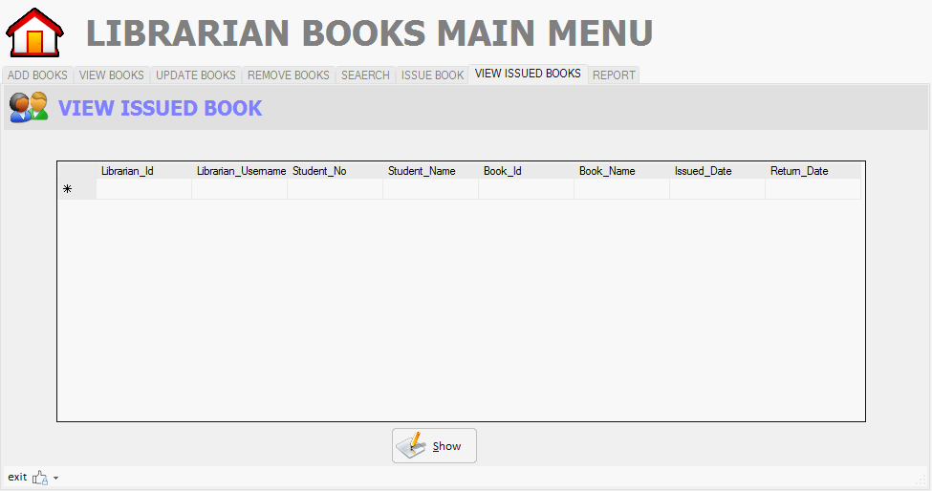

8th panel of manage books(generate report of issued books)
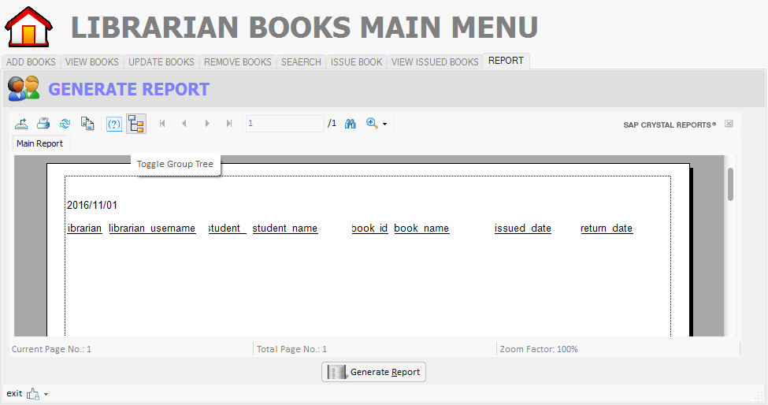

When you click manage student

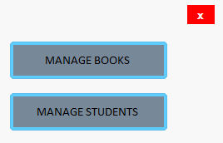
The first panel of manage student (add new student)

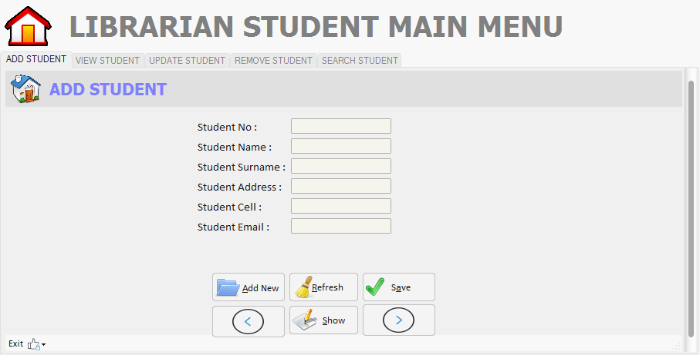

The second panel of manage student(view all student)
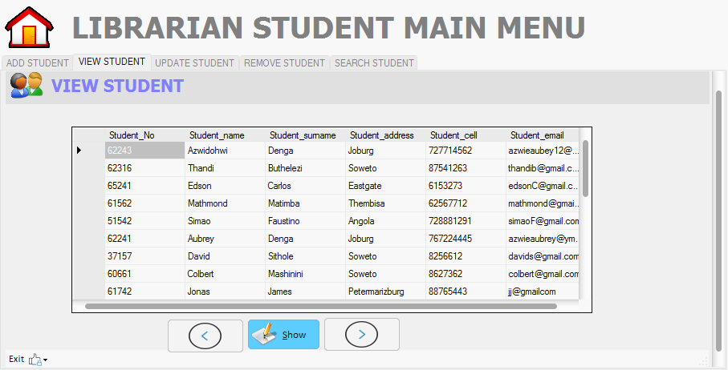

The third panel of manage student(update student)
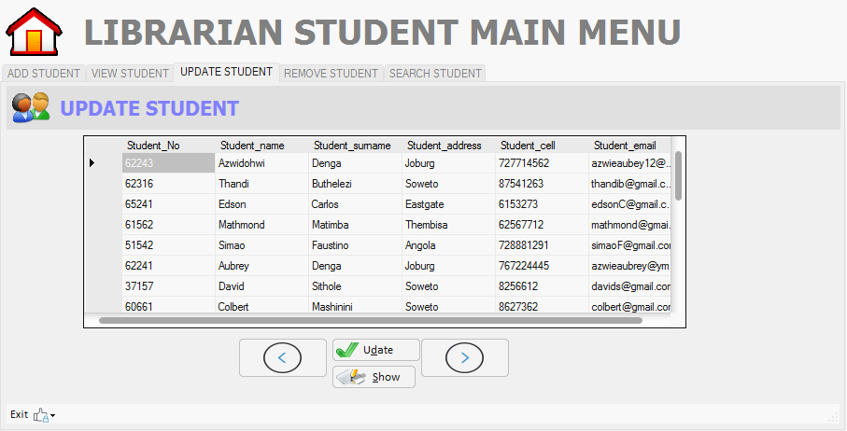

The fourth panel of manage student(remove student)
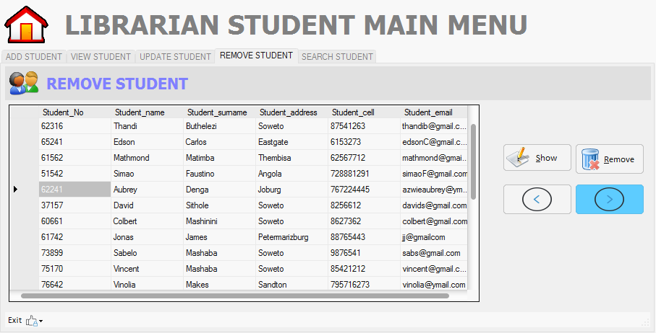

The firth panel of mange student(search student)
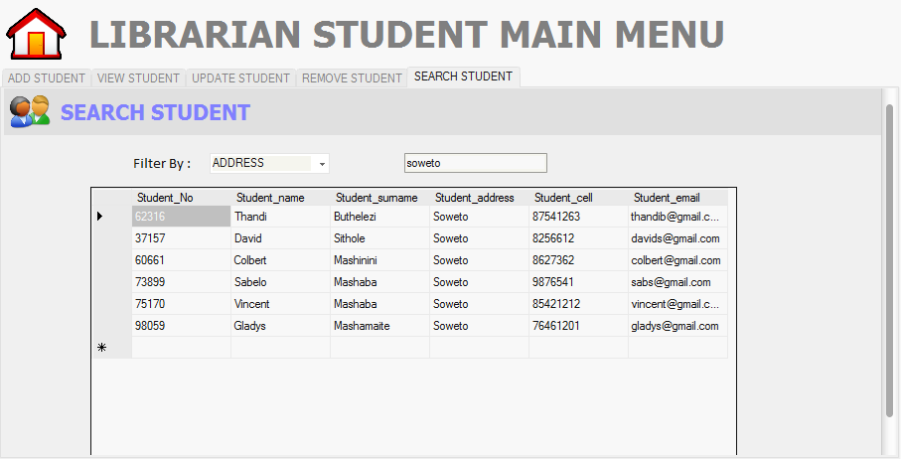

6. Database Description

The Database for Library Management System consists of five tables. They are:
Admin
Librarian
Books
Students
Issued books
6.1 Description of Each Table

Admin Table

The Admin table stores all the details of the admin of the system. The admin table consists of three attributes which are admin id, admin username, Admin password and admin id is the primary key for this table.

Librarian Table

The Librarian table stores all the details of the Librarian of the system. The Librarian table consists of eight attributes which are Librarian id, Librarian name, Librarian surname, Librarian username, Librarian password, Librarian address, Librarian cell, Librarian email and Librarian id is the primary key for this table.

Issue Details Table

The IssueDetails Table stores the details of the books issued. It will store information like whom the book is issued to, on which date the book is issued, when the book is expected to return ,the return date ,details of the copy with its ID.The attributes of this table are Librarian id, Librarian name, Student number, student name, book id, book name, issue date and return date.

Books Table

The Books table stores all the details of the Books of the system books that have been added on the database. The Books table consists of eight attributes which are book_id, book_name, book_description, category, author, publisher, year, isbn.. and the primary key is book_id

Student Table

The Student table stores all the details of the Student that have been added on the database. The Student table consists of six attributes which are student_no, student_name, student_surname, student_address, student_cell, student_Email

6.2 Relational Data Structures

Admin(admin_id, admin_username,admin_password)
Books(book_id,book_name,book_description,category,author,publisher,year,isbn)
Issue(librarian_id,librarian_name,student_no,student_name,book_id,book_name,issue_date,return_date)
Librarian(librarian_id,librarian_name,librarian_surname,librarian_username,librarian_password,librarian_address,librarian_address,librarian_cell,librarian_email)
Student(student_no,student_name,student_surname,student_address,student_cell,student_email)

6.4 Relational Database Schema
Table Name | Attributes | Type | Description
Admin | Admin_id | Int | Primary Key
 | Admin_username | Varchar
 | Admin_password | Varchar
Books | Book_id | Int | Primary Key
 | Book_name | Varchar
 | Book_description | Varchar
 | Category  Author  publisher  year  isbn | Varchar  Varchar  Varchar  Date  Int
Issue | Librarian_id | int | Primary Key
 | Librarian_name | varchar
 | Student_no | int
 | Student_name | varchar
 | Book_id | int
 | Book_name | varchar
 | Issue_date | date
 | Return_date | Date
Librarian | Librarian_id | int | Primary Key
 | Librarian_name | varchar
 | Librarian_surname | varchar
 | Librarian_username | varchar
 | Librarian_password | varchar
 | Librarian_address | varchar
 | Librarian_cell | Int
 | Librarian_email | varchar
Student | Student_no | int | Primary Key
 | Student_name | varchar
 | Student_surname | varchar
 | Student_address | varchar
 | Student_cell | int

6.5Data Dictionary

Name Used in the system

Name Used in the system | Description
Admin  Admin_id  Admin_username  Admin_password | Table name which contains the information of the admin  Unique number of the administrator  Username of the administrator  Password of the administrator
Books  Book_id  Book_name  Book_description  Category  Author  publisher  year  isbn | Table name which contains the information of the book  Number given to each book  Name of the book  Description of the book  Category of the books or specification  Name of the book author  Name of the book publisher  Year which book has been published  ISBN number of the book
Issue  Librarian_id  Librarian_name  Student_no  Student_name  Book_id  Book_name  Issue_date  Return_date | Table name which contains the information of the issue and return books  Unique identification that has been given to librarian  Name of the librarian  Unique identification number that user use and it can not be shared  Name of the student  Unique number of the book  Name of the book  Date when the issue is done  When the book will is returned
Librarian  Librarian_id  Librarian_name  Librarian_surname  Librarian_username  Librarian_password  Librarian_address  Librarian_cell  Librarian_email | Table name which contains the information of the librarian  Unique identification that has been given to librarian  Name of the librarian  surname of the librarian  username of the librarian  password of the librarian  address of the librarian  cell phone number of the librarian  email of the librarian
Student  Student_no  Student_name  Student_surname  Student_address  Student_cell | Table name which contains the information of the student  Unique identification number that user use and it cannot be shared  Name of the student  Surname of the student  Address of the student  Cell number of the student

End Users of This Database

The end users of this database are:

The main client who will be using Library Management System is Group One
Students of Richfield Graduate Institution Of Technology
Librarian of Richfield Graduate Institution Of Technology

Administrators of This Database

The Librarian will be the administrators of this database.
The management staff who are appointed as administrators for the Library.

2.1Context Diagram for Library Management System

Software Requirements Specification
1. Introduction

1.1. Purpose

The main objective of this document is to illustrate the requirements of the project Library Management system. The document gives the detailed description of the both functional and non functional requirements proposed by the client. The document is developed after a number of consultations with the client and considering the complete requirement specifications of the given Project. The final product of the team will be meeting the requirements of this document.

1.2. Document Conventions

The following are the list of conventions and acronyms used in this document and the project as well:
- Administrator: A login id representing a user with user administration privileges to the software
- User: A general login id assigned to most users
- Client: Intended users for the software
- SQL: Structured Query Language; used to retrieve information from a database
- SQL Server: A server used to store data in an organized format
- Layer: Represents a section of the project
- User Interface Layer: The section of the assignment referring to what the user interacts with directly.
- Data Storage Layer: The section of the assignment referring to where all data is recorded
- Data flow diagram: It shows the dataflow between the entities.
- Use Case: A broad level diagram of the project showing a basic overview
- Interface: Something used to communicate across different mediums
- Unique Key: Used to differentiate entries in a database

1.3. Intended Audience and Reading Suggestions

The intended audiences for this document are:
- The team members of Innovative library Solutions.
- The librarian of the college who is the client.
- The Project Supervisor and Project Coordinator.

This document will be reviewed frequently by the above audiences to check if the different phases of the project are being completed by meeting the given requirements.

2. Overall Description

2.1 Product Perspective

The proposed Library Management System which is being developed by Group One Library Management Solutions team is an Library Management System. This System will provide a search functionality to facilitate the search of resources. This search will be based on various categories viz. book name or the ISBN. Also Advanced Search feature is provided in order to search various categories simultaneously. Further the library personnel can add/update/remove the resources and the resource users from the system.

2.2 Product Features

There are two different users who will be using this product:

- Admin who will be acting as the administrator
- Librarian of the School who will be the one who is issuing the books and delete/add/update.

The features that are available to the Librarian are:

- A librarian can issue a book to the student
- A librarian can issue a book to the student
- Can view The different categories of books available in the Library
- Can view the List of books available in each category
- Can take the book returned from students
- Add books and their information of the books to the database
- Edit the information of the existing books.
- Can check the report of the issued Books.
- Can access all the accounts of the students.

The features available Admin

- Can add/delete/update the librarian.
- Can own an account in the library
- Can view the report of all books available in the library
- Can view the report of all students in the school
- Can view the history of books issued to him previously
- can add/remove/update a new or old admin

2.3 User Classes and Characteristics

There are various kinds of users for the product. Usually web products are visited by various users for different reasons.

The users include:

- Librarian who will be using the above features by accessing the Library.
- Admin who will be acting as the controller and he will have all the access to the system.

2.4 Operating Environment

The product will be operating in windows environment. Also it will be compatible with the IE 6.0. Most of the features will be compatible with the Microsoft visual basic 2010 or higher version.

2.5 Design and Implementation Constraints

The Product is developed using C#. The backend database for this MySQL Server. The product is accomplished with login facility so that specific function is available to specific librarian.

2.6 User Documentation

The product will include user manual. The user manual will include product overview, complete configuration of the used software (such as SQL server), technical details, backup procedure and contact information which will include email address. There will be no online help for the product at this moment. The product will be compatible with Microsoft visual basic 2010 or higher. The databases will be created in the MySQL.

2.7 Assumptions and Dependencies

The product needs following third party product.

- MySQL server to store the database.
- C# to develop the Product/ System

3. System Features

3.1. Database – Storage

3.1.1. Description and Priority

Proposed Database is intended to store, retrieve, update, and manipulate information related to college which include

- Books Details
- Librarian information
- Student details

3.1.2. Stimulus / Response Sequences

Responses for Administrator: The administrator can Login and Logout. When the Administrator Logs into the Library system. The system will check for validity of login .If the Login and password are valid, the response to this action is the administrator will be able to modify, view, add, deleting and all other functions that can be performed on the database.

3.2. Functional Requirements

This section gives the list of Functional and non functional requirements which are applicable to the Library Management System.

3.2.1 Interface Requirements

This section describes how the software interfaces with other software products or users for input or output.

3.2.1.1UserInterfaces
Describes how this product interfaces with the user.

GUI - Describes the graphical user interface if present. This section should include a set of screen dumps or mockups to illustrate user interface features.

Description - The user interface must be customizable by the administrator

Criticality- This issue is essential to the overall system. All the modules provided with the software must fit into this graphical user interface and accomplish to the standard defined.

Technical issues - In order to satisfy this requirement the design should be simple and all the different interfaces should follow a standard template. There will be the possibility of changing colors and images, plus switching between interfaces with the minimum impact for the users.

4. Non Functional Requirements

4.2. Hardware Interfaces
Server Side:
- Operating System: Windows 9x/xp/7/8/10 ,Windows ME
- Processor: Pentium 3.0 GHz or higher
- RAM: 512 Mb or more
- Hard Drive: 10 GB or more
Client side:
- Operating System: Windows 9x or above, MAC or UNIX.
- Processor: Pentium III or 2.0 GHz or higher.
- RAM: 256 Mb or more

4.3. Software Interfaces

- Database: SQL Server.
- Application: c#

5. Other Nonfunctional Requirements

5.1. Performance Requirements
The proposed system that we are going to develop will be used as the Chief performance system within the different campuses of the school which interact with the college librarian and students. Therefore, it is expected that the database would perform functionally all the requirements that are specified by the school.

5.2. Safety Requirements
The database may get crashed at any certain time due to virus or operating system failure. Therefore, it is required to take the database backup.

5.3. Security Requirements
We are going to develop a secured database for the school .There are different categories of users namely teaching staff, administrator, library staff, students etc., Depending upon the category of user the access rights are decided. It means if the user is an administrator then he can be able to modify the data, delete, append etc., All other users other than library staff only have the rights to retrieve the information about database.

5.4. Software Quality Attributes
The Quality of the database is maintained in such a way so that it can be very user friendly to all the users of the database.

5.5 Hardware Constraints
The system requires a database in order to store persistent data. The database should have backup capabilities.

5.6 Software Constraints
The development of the system will be constrained by the availability of required software such as servers, database and development tools.

